# Telepresence System - Project Brief

This document will outline and describe the Telepresence System project I will be undertaking.

# Introduction

Telepresence is a concept that has been depicted in TV shows and cartoons for as long as I can remember. Broadly speaking, it is the ability for an individual to feel as though they exist in a different environment. The challenge in telepresence is stimulating the human senses enough to trick them into believing that the environment they are sensing is a reality.

In the Telepresence System project, I will aim to create a method of interacting with a system using a process which will feel natural to the user. I will aim to minimise the amount of knowledge required to use the system, whilst still retaining a level of practicality within the system.

# Hardware

The following is the hardware I have available to me in this project.

**Nao Robot** – a humanoid robot developed by Aldebaran Robotics. The robot has a multitude of sensors and can be programmed to carry out a wide array of tasks. [Figure 1]

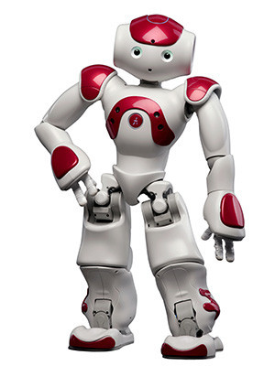

Figure

**Myo Armband** – a gesture recognition armband developed by Thalmic Labs. The armband uses a combination of multiple EMG sensors, a gyroscope, an accelerometer and a magnetometer to detect gestures and motion. [Figure 2]

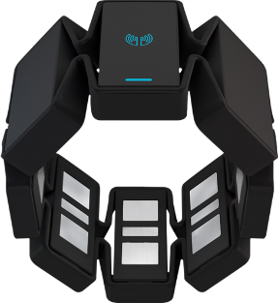

Figure

**Leap Motion** – a small panel which uses motion detectors to create a “field” above the panel which the user can interact. [Figure 3]

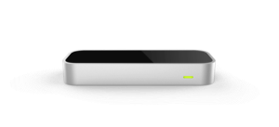

Figure

**Oculus Rift DK2** – a head mounted virtual reality device which requires extensive graphics processing to simultaneously stream two feeds to high-tech lens for each eye. This device comes with a desktop based motion sensor which can capture 3D movement of the device. [Figure 4]

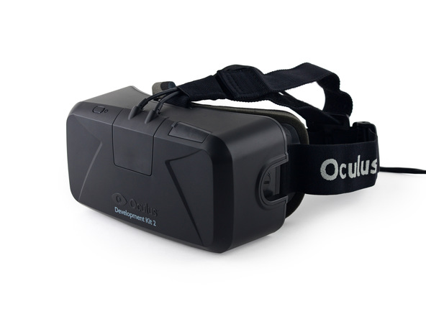

Figure

# Project Aims

The aim of this project is to develop an interface with the following features:

* The user will be able to have some degree of control the limbs of the Nao Robot through hand gestures and/or motion control
  + Input: Leap/Myo (motion)
  + Output: Nao (controlled movement)
* The user will be able to have some degree of control of the head of the Nao Robot through head tracking
  + Input: DK2 (motion)
  + Output: Nao (controlled movement)
* The user will be able to instruct the Nao Robot to move around the room using simple voice commands
  + Input: Nao (microphone)
  + Output: Nao (programmed actions)
* The user may be able to access a camera on the Nao Robot through the Oculus Rift device
  + Input: Nao (camera)
  + Output: DK2 (image feed)

# AOB

* Each device has libraries in C++ so for consistency across platforms, this is the language I will be using.
* I will be integrating each SDK into a QT application to simplify the connections between the hardware.
* I will probably be using git for version control.
* Challenges
  + Lots of time is required at the start of the project to understand what the project is
  + Learning curves working with new hardware/environments/concepts
  + Access to Nao is limited
  + Multiple work environments
* May be utilising an open source HMD SDK rather than Oculus SDK.
* Useful Contacts
  + Project Supervisor, Firat
  + Previous project student, Abhishek
  + Other students working with hardware, Matt T, Abby A
  + Arup
    - Simon Lewis
    - Alvise Simondetti

# Project Timeline – Short Term

# Project Timeline – Long Term

